St. Isaac Jogues Faith Formation
2022-2023 Sacramental Preparation Calendar
Reconciliation & Eucharist
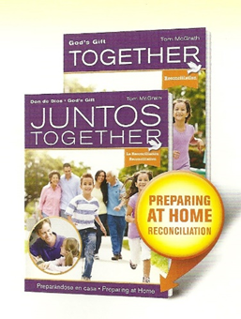
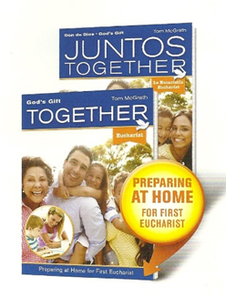
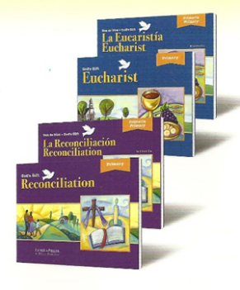

Text: God’s Gift (2016). Loyola Press
https://www.loyolapress.com/faith-formation/sacramental-preparation/gods-gift-2016/

*Sacramental Orientations for Parents and Students
* Catechist/Student Sessions – 3 for Reconciliation & 4 for Holy Eucharist
* Catechist Bilingual Parent/Guardian Sacramental Sessions – 3 for Reconciliation & 4 for Holy Eucharist
* Home Lessons / Parent Led – 3 for Reconciliation 4 for Holy Eucharist
* Holy Eucharist Retreat
* Celebration of the Sacraments (Including Rehearsals)

All In-Person Sessions are on Thursdays from 6:30-8:00 PM beginning in the Church
with Sign-In from 6:15 pm - 6:30 pm.
September 22 | Reconciliation Orientation | Catechist /Student Session
October 6 | Rec – God Calls Us Friends – Chapter 1 | Catechist /Student Session
October 13 | Rec – Jesus Saves Us – Chapter 2 | Home Lesson / Parent Led
October 20 | Rec – Jesus Forgives Us – Chapter 3 | Catechist /Student Session
October 27 | Rec – Jesus Heals Us – Chapter 4 | Home Lesson / Parent Led
November 3 | Rec – The Holy Spirit Guides Us – Chapter 5 | Catechist/Student Session
November 10 | Rec – God Is Always With Us – Chapter 6 | Home Lesson / Parent Led
December 13 | 1st Reconciliation & Advent Penance Service | Gathered in Church
January 5, 2023 | Holy Eucharist Orientation | Catechist /Student Session
January 12 | Holy Eucharist – Belonging – Chapter 1 | Catechist /Student Session
January 19 | Holy Eucharist – Gathering – Chapter 2 | Home Lesson / Parent Led
January 26 | Holy Eucharist – Reflecting – Chapter 3 | Catechist /Student Session
February 2 | Holy Eucharist – Listening – Chapter 4 | Home Lesson / Parent Led
February 9 | Holy Eucharist – Preparing – Chapter 5 | Catechist /Student Session
February 11 | Holy Eucharist Retreat (9 am - 1 pm) | Gathered in Parish Hall
February 16 | Holy Eucharist – Remembering – Chapter 6 | Home Lesson / Parent Led
March 2 | Holy Eucharist – Receiving – Chapter 7 | Catechist/Student Session
March 9 | Holy Eucharist – Journeying – Chapter 8 | Home Lesson / Parent Led
April 13 | Holy Eucharist Rehearsal (English) | Gathered in Church
April 14 | Holy Eucharist Rehearsal (Spanish) | Gathered in Church
April 22 & 23 | Holy Eucharist Masses | Gathered in Church

